LAPORAN PRAKTIKUM
APLIKASI BERBASIS PLATFORM

PERTEMUAN 12
MOBILE


Disusun oleh:
MUHAMMAD ARSYAD ZAIDAN
2311102058
S1 IF-11-04

Dosen Pengampu:
Cahyo Prihantoro, S.Kom., M.Eng

PROGRAM STUDI S1 INFORMATIKA
FAKULTAS INFORMATIKA
TELKOM UNIVERSITY PURWOKERTO
2025/2026

LINK GITHUB : https://github.com/marsyadzaidan/TugasABPTugas-Laprak_2311102058

1. Main.dart Source code :

import 'dart:io';
import 'package:flutter/material.dart'; import 'package:image_picker/image_picker.dart'; import
'package:flutter_local_notifications/flutter_local_noti fications.dart';
final FlutterLocalNotificationsPlugin flutterLocalNotificationsPlugin = FlutterLocalNotificationsPlugin();

void main() {
runApp(const MyApp());
}
class MyApp extends StatelessWidget { const MyApp({super.key});

@override
Widget build(BuildContext context) { return MaterialApp(
debugShowCheckedModeBanner: false, title: 'Notifikasi & API Perangkat Keras', theme: ThemeData(primarySwatch: Colors.blue), home: const HomePage(),
);
}
}
class HomePage extends StatefulWidget { const HomePage({super.key});

@override
State<HomePage> createState() => _HomePageState();
}
class _HomePageState extends State<HomePage> { File? _image;
final ImagePicker _picker = ImagePicker();

@override void initState() { super.initState();
_initializeNotifications();
}

Future<void> _initializeNotifications() async { const AndroidInitializationSettings androidSettings
=
AndroidInitializationSettings('@mipmap/ic_launc her');

const InitializationSettings settings = InitializationSettings(
android: androidSettings,
); await
flutterLocalNotificationsPlugin.initialize(settings);
await flutterLocalNotificationsPlugin .resolvePlatformSpecificImplementation<
AndroidFlutterLocalNotificationsPlugin
>()
?.requestNotificationsPermission();
}

Future<void> _showNotification(String message) async
{
const AndroidNotificationDetails androidDetails =
AndroidNotificationDetails(
'photo_channel', 'Photo Notifications', channelDescription:
'Notifikasi saat foto berhasil dipilih atau diambil',
importance: Importance.max, priority: Priority.high,
);

const NotificationDetails notificationDetails = NotificationDetails(
android: androidDetails,
);
await flutterLocalNotificationsPlugin.show(
DateTime.now().millisecond, 'Praktikum Flutter', message,
notificationDetails,
);
}

Future<void> _pickFromCamera() async { final XFile? photo = await
_picker.pickImage(source: ImageSource.camera);

if (photo != null) { setState(() {
_image = File(photo.path);
});
await _showNotification('Foto berhasil diambil dari kamera');
}
}

Future<void> _pickFromGallery() async { final XFile? photo = await
_picker.pickImage(source: ImageSource.gallery);
if (photo != null) { setState(() {
_image = File(photo.path);
});

await _showNotification('Foto berhasil dipilih dari galeri');
}
}

@override
Widget build(BuildContext context) { return Scaffold( appBar: AppBar( title: Column(
mainAxisAlignment: MainAxisAlignment.center, children: [ const Text(
'Muhammad Arsyad Zaidan', style: TextStyle(fontSize: 20, fontWeight: FontWeight.bold),
),
const Text(
'Tambah foto dari camera/galeri', style: TextStyle(fontSize: 14, fontWeight: FontWeight.normal),
),
], ),
centerTitle: true, toolbarHeight: 70,
),
body: Padding(
padding: const EdgeInsets.all(20), child: Column( children: [ Expanded( child: Center(
child: _image == null
? const Text(
'Belum ada foto dipilih', style: TextStyle(fontSize: 18),
)
: Image.file(_image!, fit:
BoxFit.contain),
), ),
const SizedBox(height: 20), SizedBox(
width: double.infinity, child: ElevatedButton.icon(
onPressed: _pickFromCamera, icon: const Icon(Icons.camera_alt), label: const Text('Buka Kamera'),
), ),
const SizedBox(height: 15), SizedBox(
width: double.infinity, child: ElevatedButton.icon( onPressed: _pickFromGallery, icon: const Icon(Icons.photo_library), label: const Text('Pilih dari Galeri'),
),
),
],
),
),
);
}
}

Penjelasan :
Aplikasi yang dirancang secara khusus untuk mengintegrasikan fitur pengambilan gambar serta akses galeri dengan sistem pemberitahuan langsung pada perangkat Android. Pada saat aplikasi pertama kali dijalankan oleh pengguna, sistem secara otomatis memicu dialog permintaan izin (permission requests) guna mengaktifkan fungsionalitas notifikasi lokal serta akses perangkat keras kamera.
Di dalam antarmuka utama aplikasi, yang mengusung identitas personal pada bagian header, disediakan dua tombol interaktif sebagai kendali utama operasional. Tombol pertama berfungsi untuk menginisialisasi kamera bawaan perangkat agar pengguna dapat menangkap momen secara langsung, sedangkan tombol kedua dialokasikan untuk membuka pustaka galeri guna memilih gambar yang telah tersimpan sebelumnya.
Alur kerja aplikasi berjalan secara simultan; segera setelah pengguna menyelesaikan proses pengambilan atau pemilihan gambar, sistem akan mengeksekusi dua tindakan sekaligus. Pertama, berkas foto yang berhasil didapatkan akan langsung dimuat dan ditampilkan di area tengah layar sebagai pratinjau (preview) adaptif. Kedua, aplikasi akan memicu framework notifikasi lokal untuk memunculkan pesan pemberitahuan instan (banner notification) di bagian atas layar handphone, yang berfungsi sebagai konfirmasi formal bahwa tindakan penambahan foto telah berhasil diselesaikan dengan aman.

2. AndroidManifest.xml

Source code :
<manifest
xmlns:android="http://schemas.android.com/apk/res/android">
<uses-permission
android:name="android.permission.CAMERA"/>
<uses-permission
android:name="android.permission.POST_NOTIFICATIONS"/>

<application
android:label="NotifAplikasi_2311102058" android:name="${applicationName}" android:icon="@mipmap/ic_launcher">

<activity
android:name=".MainActivity" android:exported="true" android:launchMode="singleTop" android:taskAffinity=""
android:theme="@style/LaunchTheme"
android:configChanges="orientation|keyboardHidden |keyboard|screenSize|smallestScreenSize|locale|layoutDirectio n|fontScale|screenLayout|density|uiMode" android:hardwareAccelerated="true"
android:windowSoftInputMode="adjustResize">

<meta-data
android:name="io.flutter.embedding.android.Norm alTheme"
android:resource="@style/NormalTheme"
/>

<intent-filter> <action
android:name="android.intent.action.MAIN"/>
<category
android:name="android.intent.category.LAUNCHER"/>
</intent-filter>
</activity>

<receiver
android:name="com.dexterous.flutterlocalnotifications.Schedul edNotificationReceiver" android:exported="false" />
<receiver
android:name="com.dexterous.flutterlocalnotifications.Schedul edNotificationBootReceiver" android:exported="false">
<intent-filter> <action
android:name="android.intent.action.BOOT_COMPLETED"/>
<action
android:name="android.intent.action.MY_PACKAGE_REPLACED"/>
<action
android:name="android.quickboot.POWERON"/>
<action
android:name="com.htc.intent.action.QUICKBOOT_POWERON"/>
</intent-filter>
</receiver>

<meta-data
android:name="flutterEmbedding" android:value="2" />
</application>

<queries>
<intent> <action
android:name="android.intent.action.PROCESS_TEXT"/>
<data android:mimeType="text/plain"/>
</intent>
</queries>
</manifest>

Penjelasan :
Dokumen konfigurasi AndroidManifest.xml ini berfungsi untuk mendaftarkan izin akses perangkat keras kamera dan otorisasi pengiriman notifikasi pada sistem operasi Android. Di dalamnya, nama aplikasi diatur melalui atribut label sekaligus menetapkan MainActivity sebagai titik masuk utama saat aplikasi dijalankan oleh pengguna. Selain itu, file ini mendaftarkan komponen penerima pesan (receiver) agar sistem notifikasi lokal tetap dapat berfungsi dengan stabil dan responsif di latar belakang perangkat.

3. Pubspec.yaml Source code :
name: Pertemuan12_2311102058
description: "A new Flutter project."
# The following line prevents the package from being accidentally published to
# pub.dev using `flutter pub publish`. This is preferred for private packages.
publish_to: 'none' # Remove this line if you wish to publish to pub.dev

# The following defines the version and build number for your application.
# A version number is three numbers separated by dots, like 1.2.43
# followed by an optional build number separated by a
+.
# Both the version and the builder number may be overridden in flutter
# build by specifying --build-name and --build-number, respectively.
# In Android, build-name is used as versionName while build-number used as versionCode. # Read more about Android versioning at
https://developer.android.com/studio/publish/versioning
# In iOS, build-name is used as
CFBundleShortVersionString while build-number is used as CFBundleVersion.
# Read more about iOS versioning at
#
https://developer.apple.com/library/archive/documentati on/General/Reference/InfoPlistKeyReference/Articles/Cor eFoundationKeys.html
# In Windows, build-name is used as the major, minor, and patch parts

# of the product and file versions while build-number is used as the build suffix.
version: 1.0.0+1
environment: sdk: ^3.11.5

# Dependencies specify other packages that your package needs in order to work.
# To automatically upgrade your package dependencies to the latest versions
# consider running `flutter pub upgrade --majorversions`. Alternatively,
# dependencies can be manually updated by changing the version numbers below to
# the latest version available on pub.dev. To see which dependencies have newer
# versions available, run `flutter pub outdated`. dependencies: flutter:
sdk: flutter image_picker: ^1.1.2
flutter_local_notifications: ^17.2.1

# The following adds the Cupertino Icons font to your application.
# Use with the CupertinoIcons class for iOS style icons.
cupertino_icons: ^1.0.8
dev_dependencies: flutter_test: sdk: flutter

# The "flutter_lints" package below contains a set of recommended lints to
# encourage good coding practices. The lint set provided by the package is
# activated in the `analysis_options.yaml` file located at the root of your
# package. See that file for information about deactivating specific lint
# rules and activating additional ones.
flutter_lints: ^6.0.0

# For information on the generic Dart part of this file, see the
# following page: https://dart.dev/tools/pub/pubspec

# The following section is specific to Flutter packages. flutter:

# The following line ensures that the Material Icons font is
# included with your application, so that you can use the icons in
# the material Icons class. uses-material-design: true

# To add assets to your application, add an assets section, like this:
# assets:
# - images/a_dot_burr.jpeg
# - images/a_dot_ham.jpeg

# An image asset can refer to one or more resolutionspecific "variants", see
# https://flutter.dev/to/resolution-aware-images
# For details regarding adding assets from package dependencies, see
# https://flutter.dev/to/asset-from-package

# To add custom fonts to your application, add a fonts section here,
# in this "flutter" section. Each entry in this list should have a
# "family" key with the font family name, and a
"fonts" key with a
# list giving the asset and other descriptors for the font. For # example:
# fonts:
# - family: Schyler
# fonts:
# - asset: fonts/Schyler-Regular.ttf
# - asset: fonts/Schyler-Italic.ttf
# style: italic
# - family: Trajan Pro
# fonts:
# - asset: fonts/TrajanPro.ttf
# - asset: fonts/TrajanPro_Bold.ttf
# weight: 700
#
# For details regarding fonts from package dependencies,
# see https://flutter.dev/to/font-from-package

Penjelasan :
File konfigurasi pubspec.yaml ini berfungsi untuk mendaftarkan dependensi atau pustaka pihak ketiga yang diperlukan dalam pengembangan proyek Flutter. Package image_picker ditambahkan agar aplikasi memiliki kemampuan untuk mengakses perangkat keras kamera serta membuka galeri foto lokal pada perangkat. Sementara itu, package flutter_local_notifications disematkan guna menyediakan infrastruktur yang diperlukan untuk membuat dan menampilkan sistem pemberitahuan langsung di layar HP pengguna.

- Output code :
1. Home
- Halaman yang menunjukan fitur ambil foto dan galeri (kondisi belum ambil foto).
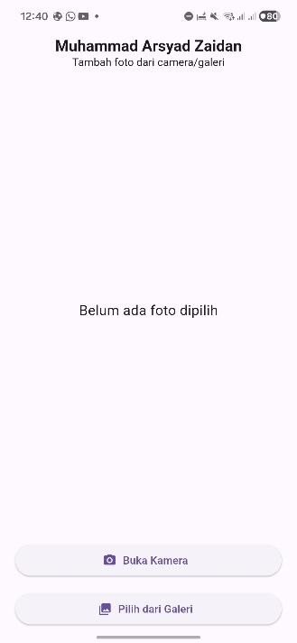

2. Camera
- Berikut adalah foto dari camera.

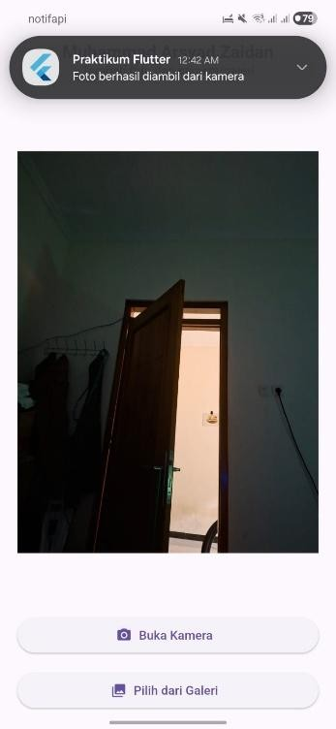

3. Galleri
- Sebelum mengambil foto dari galeri, diperlukan izin dari android. Pilih allow saja dan foto lalu foto akan ter-upload.
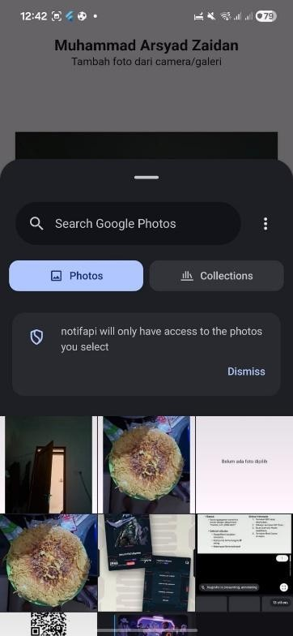

- Berikut kondisi ketika foto galeri sudah selesai di-upload
